MATHEMATICS
COMPETENCE BASED CURRICULUM FORMATIVE ASSESSMENT SUMMARISED JSS HOLIDAY ASIGNMENT. END YEAR 2025

- A milling factory produced 85147000 kg of maize flour in the year 2023.
  - Fill in the number of kilograms produced in the two years in the place value chart below.( 2mks)
8 | 5 | 4 | 1 | 4 | 7 | 0 | 0 | 0
 |  |  |  |  |  |  |  | Ones

- What is the place value of digit 6 after working out the sum of 235,652 and 2,465,021? (1 marks)

- What is the total value of digit 7 after working out the product of 879 and 54? (1 marks)

- What is eighty eight million, six hundred and three thousand and eight less a thousand? (1 marks)

- Round off 587,890 to the nearest hundreds of thousands. (1 mark)

- What is the distance round the circular swimming pool below of radius 7m? ( 2mks)

- Find the value of x in the following (2 Mks)
$$15x-60=130+5x$$

- If r=5, s=2, and t=3, find the value of; (3mks)

$\frac{r^{2}+s^{2}-t}{t^{3}}$

- Calculate the perimeter of the triangle below.(2 mks)

(x+3) cm (x+3) cm

(2x+1) cm
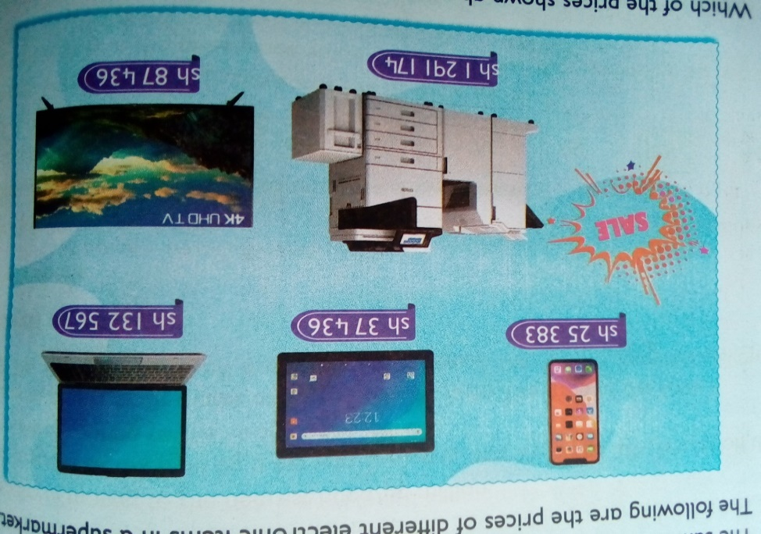
- Olive went to a supermarket to buy digital devices. She saw them displayed as follows:

  - What was the price of a mobile phone? ( 1mk)

  - Of the 5 items, which one was the biggest in size? ( 1mk)

  - How much more was the printer than the laptop?( 1 mk)

- Arrange the following numbers in ascending order. ( 1mks)

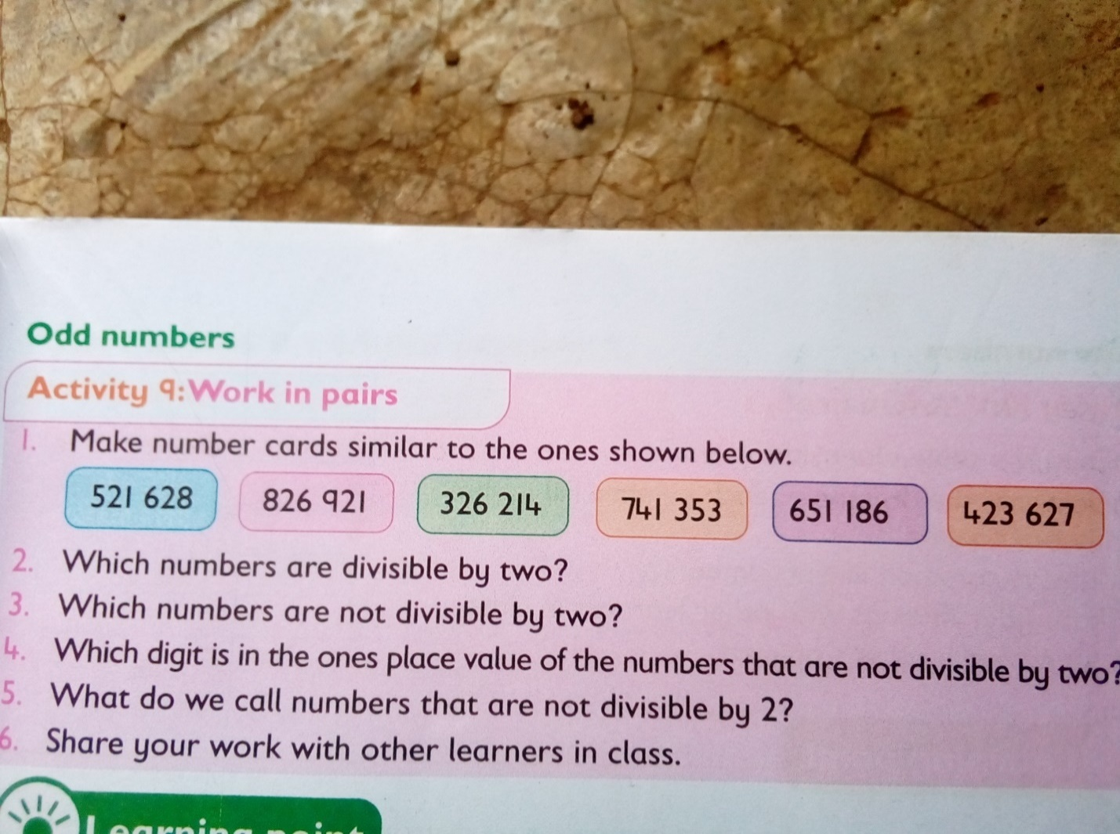

- What is the sum of all prime numbers between 10 and 30? (2 marks)

- Work out the following. (2 marks)
$$63-9×12÷4+28$$

- A certain man won a prize of Kenya shillings sixty million, forty-five thousand, two hundred and ninety. What is this prize written in symbols? (1mk)
- What is the sum of total values of the digits in the hundreds and ten thousands position in the number 740,536? (2mk)

- Work out: (2mk)

45-7x6÷ 12

- Nagoya worked out the difference of LCM of 12 and 24 and the G.C.D of 36 and 54. What answer did he get? (2mk)

- The price of a car is sh.4, 990,675. How much is the amount rounded off to the nearest thousands? (1mk)

- What is the smallest number that can be subtracted from 40658 to make it divisible by 11? (1mk).

- What is $\frac{2}{3},\frac{5}{6},\frac{3}{4}and\frac{7}{12}$ arranged in increasing order? (1mk)

. The figure below represents the net of a solid. The net is folded to form the solid. How many edges, faces and vertices will the solid have? (3mks)
No of faces=………………
No of vertices =……………….
No of edges=…………………..

- Find the area of the figure below. (2mk)

- A school bus left the school at 4.45 p.m. to transport learners’ home. What was the time in 24hrs clock system? (1mk)

- Work out: (2mk)

Tones kilograms
15 450
-6 775

- A dairy farmer sells 240 000 cm3 of milk every day. How many litres of milk does the farmer sell every day? (2mk)

- What is the value of x in the equation? (2mks)

5x+3 (x-4) =36
- Work out. (2mk)
0.072 ÷ 0.6

- The area of a rectangular plot is 576m2. What is the length of a square with the same area? (2mk)

- Work out the following .( 1mk)
$$33\frac{7}{12}+40\frac{2}{3}$$

PRETECHNICAL STUDIES
- Mention three components of pre-technical studies. (3 mks)
- ………………………………………………………
- ………………………………………………………
- ………………………………………………………

- Outline three roles of pretechnical studies in day today life. (3 mks)
- ………………………………………………………………………………………………………………
- ………………………………………………………………………………………………………………
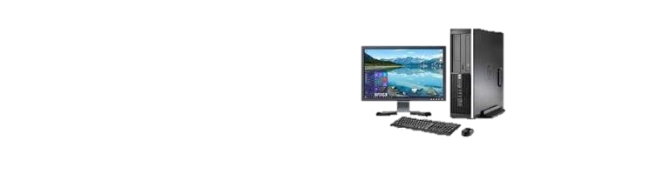
- ………………………………………………………………………………………………………………

- Name the parts of the computer shown below. (5 mks)

- Give three examples of safety measures. (3 mks)
- ……………………………………………………………………………
- ……………………………………………………………………………
- ……………………………………………………………………………

- Identify four Physical threats at workplaces. (4 mks)

- ………………………………………………………………….
- …………………………………………………………………..
- ………………………………………………………………….
- …………………………………………………………………

- Name at least four examples of online threats at work place. (4 mks)
- …………………………………………………..
- ……………………………………………………
- ……………………………………………………..
- ……………………………………………………..

- State four Ways of mitigating/reducing physical threats to digital devices.(4 mks)
- ……………………………………………………………………………
- ……………………………………………………………………………
- …………………………………………………………………………….
- …………………………………………………………………………….

- State three ideas and practices on how to personal and sensitive data from the public when online. (3 mks)
  - …………………………………………………………………….
  - …………………………………………………………………….
  - ……………………………………………………………………..

- Identify five Safety Rules and Regulations at Work.(5 mks)
  - ………………………………………………………………………
  - ………………………………………………………………………
  - ………………………………………………………………………
  - ……………………………………………………………………….
  - ………………………………………………………………………..

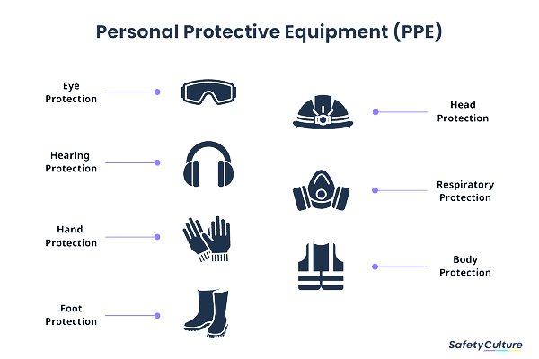
- Name the following safety wears. (7 mks)

- Give three examples of Data. (3 mks)
  - ……………………………………………………………………………………………………………………………..
  - ……………………………………………………………...

- List five examples of computers used today. (5 mks)
- …………………………………………………………………………..
- ………………………………………………………………………….
- …………………………………………………………………………
- ……………………………………………………………………………
- …………………………………………………………………………..

- State and explain three characteristics of computers. (6 mks)
- ………………………………………………………………………….....
- …………………………………………………………………………….
- ……………………………………………………………………………
- We can classify computer by looking at the following: name three. (3 mks)
- ……………………………………………………
- ……………………………………………………..
- ………………………………………………………

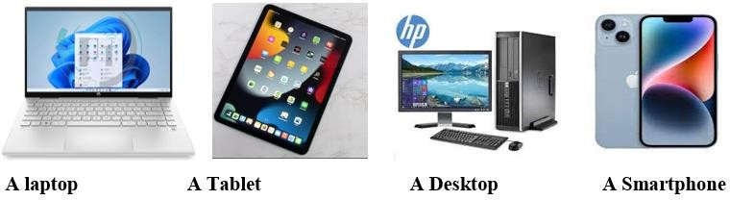
- Name the following digital computers. (4 mks)

- State two characteristics of 1st generation computers. (2mks)
- ……………………………………………………………………………..
- ……………………………………………………………………………..

- List any two computer hardware components. (2mks)
- ………………………………………………..
- ………………………………………………..

- Identify the right posture from the above illustration when using a computer. (2mks)

- Write one factor to consider when selecting appropriate hardware components. (1mk)
- ……………………………………………………………………………

SOCIAL STUDIES
- State three reasons for the migration of Nilotes.(3 mks)
- ………………………………………………………………………………
- ……………………………………………………………………………..
- ……………………………………………………………………………….
- Name two examples of volcanic mountains.(2 mks)
- ………………………………………………………………
- ………………………………………………………………

- Name any two theories explaining the origin of the earth.(2 mks)
- ………………………………………………………………………………
- …………………………………………………………………………….

- Identify the following planets. (4 mks)

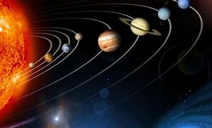

- Conditions of the atmosphere of a place at a given time is called ……………… (1 mk)

- Name two branches of social studies. (2 mks)
- ………………………………
- ………………………………

- Name two types of maps. (2 mks)
__________________________________

__________________________________

- Study the diagram on structure of the earth below and answer the questions that follow.

- Name the regions above. (3 mks)

- Write two effects of rotation and revolution of the earth.(4 mks)
Rotation of the Earth | Revolution of the Earth

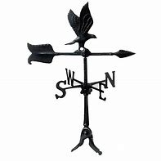
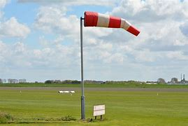
- Identify the following weather measuring instruments.(3 mks)
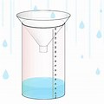

- State two factors to consider when siting a weather station.(2 mks)
- ……………………………………………………………………………………….
- ……………………………………………………………………………………….

- An area with high population is said to be ………………………………….populated whereas an area with low population is said to be …………………populated. (2 mks)

- The way of life and doing thing in a community is known as …………………(1 mk)

- List two aspects of culture in most of our communities; (2 mks)
- ……………………………………………
- ………………………………………….

- List four elements of weather; (4 mks)
- ………………………………………………
- ……………………………………………….
- ……………………………………………….
- ……………………………………………….

- Monuments, museums, historic buildings and cultural centres are referred to as
……………………………………………….. (1 mk)

- Large carvings and models that remind us of our past heroes like Jomo Kenyatta are known as ………………………………………….(1 mk)

- Name the capital cities of the following African countries.(2 mks)
- Ghana -…………………………………………..

- Ethiopia- ………………………………………….

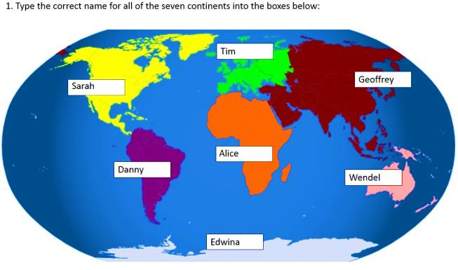
- Identify the following continents that were mentioned by the following students.(4 mks)

Tim: …………………………………………..
Wendel ………………………………………
Danny ………………………………………..
Alice …………………………………………..

- Name any two facts about planet earth.(2 mks)
- …………………………………………………………………..……………..
- ………………………………………………………………………………….
- The sun is overhead the equator on dates. (2 mks)
- ……………………………………………………..
- ………………………………………………………
- The atmosphere consists of? (3 mks)
- ……………………………………………….
- ………………………………………………..
- ………………………………………………..

- If the time in Monrovia , Liberia ,12⁰W is 8:00am, what is the time at Addis Ababa, Ethiopia, 38 ⁰E? (2 mks)

- Name Life skills that enhance negotiations during social interaction.(3 mks)
- ………………………………………….
- ………………………………………….
- ………………………………………….

- Define the following terms as used in life skills.(4 marks)
    - Personal management skills.
……………………………………………………………………………………………………………………………………………………………………………………………………….
    - Self-awareness
…………………………………………………………………………………………………………………………………………………………………………………………………………

- Define psychological dimension as used in personal management skills. (2 marks )
…………………………………………………………………………………………………………………………………………………………………………………………………………
- Outline five different dimension one uses to define himself/herself. (5 marks)
  - …………………………………………………………..
  - …………………………………………………………..
  - ……………………………………………………………
  - ……………………………………………………………
  - …………………………………………………………….
- Discuss five physical changes that happens to girls and boys during adolescence.(5 marks)
  - ……………………………………………………………………………….
  - ………………………………………………………………………………
  - ………………………………………………………………………………
  - ……………………………………………………………………………….
  - ……………………………………………………………………………….
- State four ways of maintaining personal hygiene and health during adolescence. (4 marks
  - ………………………………………………………………………………….
  - ………………………………………………………………………………….
  - ………………………………………………………………………………….
  - …………………………………………………………………………………..

- What is self-esteem? (2 marks)
…………………………………………………………………………………………………………………………………………………………………………………………………………
- Name three types of families. (3 marks)
  - ………………………………………………………………
  - ………………………………………………………………
  - ……………………………………………………………….

KISWAHILI
- UFAHAMU
Soma makala yafuatayo kisha ujibu maswali.
Nairobi, mji mkuu wa Kenya ,ni jiji Ia maajabu na mastaajabu chungu nzima.Nadhari ya mtu anayewahi kuingia jiji hili kwa mara ya kwanza huvutiwa na huo msheheneko wa majumba ya fahari, marefu ajabu ,kiasi chaminazi mitano-sita ,iliyounganishwa kuelekea juu. mbinguni.

Jumba linalowavutia watu wengi ni lile Ia makongamano ya kimataifa Iiitwalo kwa Kiingereza Kenyatta International Conference Centre Jumba hili,hadi miaka michache iliyopita, ndilo lililokuwa refu zaidi mjini Jumba lenyewe- lina ghorofa ishirini na tisa hivi ,usipohesabu hilo pambo kama kofia kileleni mwake,linalojulikana kama mwavuli. Hata hivyo ,miaka michache iliyopita jengo hili lilipitwa urefu na Mnara wa Nyakati (Times Tower).Mnara huo hasa ni jumba linaloafiki lakabu yake ya kikwaruza mawingu.Jumba hili lina ghorofa zisizopungua thelathini na mbili.
Mbali na majumba haya mawili ,kuna majumba mengine zaidi ya ishirini katikati ya jiji ambayo ,japo mengine ni mafupi kiasi ,yana maumbo ya kustaajabisha kweli kweli.Hebu zingatia mwenyewe jumba Iiitwalo “mdomo wa kengele” au “bell —bottom” ambalo ni vioo vitupu ,toka chini hadi juu.Fauka ya ,umbo lake ni Ia kipekee ulimwenguni kote. Jumba hili lina kama miguu, kisha kiuno mithili ya kinu hivi japo si mviringo.Linapaa juu ,mbali sana ,likichukua umbo pana kuliko lilivyo chini;umbo Ia fua pana kama kengele.

Halafu rudia barabara .hizi hazina hesabu katikati ya jiji na ni pana, tena safi sana.Magari yanayotumia barabara hizi ni kochokocho,ya kila ama yanashindania nafasi,

Ajabu kubwa ya Nairobi hata hivyo ni idadi ya watu.Hakuna hasa anayejua idadi kamili ya watu wa Nairobi ,lakini sio kupiga chuku ninaposema kwamba ,hasa nyakati za kuelekea kazini asubuhi ,kwenda kula chakula cha mchana ,kuelekea nyumbani baada ya kazi na kuvuka barabara wakati wa msongamano, watu hukanyangana .Mtu anayesema kwamba watu wa Nairobi ni wengi kama chungu ,au kama mchanga wa ufuo wa bahari, hatii chumvi.

Watu wa Nairobi ,kwa tabia na mavazi, si kama watu wa kwingineko nchini Kenya .Watu hawa huvalia nadhifu sana.Wanawake ni warembo ajabu na hutengeneza nywele zao mithiIi ya hurulaini peponi.Wengi huvaa suruali ndefu. Kucha zao na midomo yao hupaka rangi maridadi sana.Huzungumza Kiswahili na Kiingereza takriban wakati wote.Wanawake wengi ajabu huendesha magari yao wenyewe ,jambo ambalo litakushangaza mara tu uingiapo jijini ,hasa kama ulilelewa ukidhani maskani mwafaka ya wanawake ni jikoni peke yake;yaani kuzingatia ile falsafa kuwa “kuoa ni kupata jiko”.Wanaume nao huvaa suti safi ,maridadi na shingoni wamefunga tai stahiki yao.Wanaume hao huendesha magari na kuyaegesha karibu na afisi zao.Huingia afisini mwao kwa maringo na madaha,huku funguo za magari yao zikining’inia vidoleni. Hawa nao husema na Kiingereza kupitia puani, utadhani ni waingereza hasa.

Kwa upande mwingine ,watoto ni nadhifu kweli kweli hasa watoto wa shule.Hawa huvalia sare zilizofuliwa na kunyoshwa vizuri kwa pasi. Wake kwa waume ,shingoni huvalia tai Watoto wa shule za Nairobi huongea Kiswahili, Kiingereza na sheng,ambayo ni “lahja” yao waliyoibuni.”Lahja” hii ni mchanganyiko wa Kiswahili,Kingereza na msamiati mchache wa lugha nyingine za Wakenya zisemwazo jijini Nairobi na vitongoji vyake.

Kwa jumla ,watu wote wa Nairobi hutembea kasi sana.Hawana hata wakati wa kutembea polepole na kuangazaangaza huku na huko.lwapo wewe ni mgeni jijini,ukizubaa utapigwa kumbo na waendelee na hamsini zao kama vile hapakutokea jambo.Hili linapojiri, usidhani limefanywa maksudi.La, hasha.Ni vile tu kwamba Wanairobi hawana muda wa kupoteza.

Maswali
(a) Kwa nini majumba ya jiji la Nairobi yana majina au lakabu za Kiingereza? (ala 2)
……………………………………………………………………………………………………………………………………………………………………………………………………………….
……………………………………………………………………………………………………………………………………………………………………………………………………………….
(b) (i) Baadhi ya maajabu ya Nairobi ni barabara safi, msongamano wa magari na
majumba marefu. Ongezea maajabu mengine matatu. (ala 3)
……………………………………………………………………………………………………………………………………………………………………………………………………………….
……………………………………………………………………………………………………………………………………………………………………………………………………………….
…………………………………………………………………………………………………………………………………………………………………………………………………………….
…………………………………………………………………………………………………….

(ii) Watu wa Nairobi wanajipenda kweli kweli, Fafanua (ala 3)
…………………………………………………………………………………………………………………………………………………………………………………………………………….
…………………………………………………………………………………………………………………………………………………………………………………………………………….
…………………………………………………………………………………………………………………………………………………………………………………………………………….
…………………………………………………………………………………………………….

(c) (i) Je, Unadhani watu wa Nairobi kweli hukanyagana? Eleza ni kwa nini msimulizi
ametoa maelezo hayo (ala 1)
…………………………………………………………………………………………………………………………………………………………………………………………………………….
(ii) Unafikiri ni kwa nini hasa wanawake wa Nairobi wanaonekana nadhifu? (ala 2)
……………………………………………………………………………………………………………………………………………………………………………………………………………….
……………………………………………………………………………………………………………………………………………………………………………………………………………….
(d) Kwa nini neno “lahja” limewekwa alama za mtajo? (ala 1)
……………………………………………………………………………………………………………………………………………………………………………………………………………….
(e) Eleza maana ya maneno na tamathali za usemi zifuatazo. (ala 3)
(i) Nadhari
…………………………………………………………………………………………………………………………………………………………………………………………………………….

- Linaloafiki
…………………………………………………………………………………………………………………………………………………………………………………………………………….

(iii) Waendelee na hamsini zao
…………………………………………………………………………………………………………………………………………………………………………………………………………….

2. UFUPISHO

Kiswahili nchini Kenya kilisambazwa kwa njia ya biashara kutoka upwa wa Kenya kwenda bara yake ,ingawa si kwa wingi sana kwa sababu wenyeji wa upwa wa Kenya —Mombasa, Siu na Pate-walikuwa katika vita vya kupigana na utawala wa Kisultani wa Seyyid Said, Sayyid Majid na Seyyid Barrgash.Hata hivyo kuna baadhi ya misafara iliyokwenda bara na kueneza Kiswahili.Kwa mfano, Waswahili wa kutoka Jomvu na Mvita walifanya biashara na Wakamba.Baadhi yao walioa Ukambani na mpaka wa leo kuna milango ya Waswahili ambao nyanya zao wanatoka Ukambani.Wafanyabiashara wengine Waswahili walifika mpaka Umaasaini.
Utawala wa kikoloni ulikitweza sana Kiswahili. Waingereza walitilia mkazo utumiaji wa lugha za kikabila kwa vile walisema kwamba mtu angeeleza hisia zake vizuri kwa kutumia lugha yake ya kwanza.Kiswahili kilitwezwa na kuchukuliwa kuwa ni lugha ya maboi.Wajerumani walikitweza sana nchini Kenya.Wamisheni pia walikipinga Kiswahili kwa sababu ya ufungamanao na Uislamu,
Hata hivyo, Kiswahili kilikuwa kinatumika katika mawasiliano, kwa hivyo wakakata shauri kwamba kitumike katika kufundashia shuleni.Lugha za makabila zilitumiwa katika madarasa ya chini-Kiswahili katika madarasa ya kati, na Kiingereza katika madarasa ya juu.Mtihani wa Kenya African Preliminary Examination (KAPE), ulikuwa ukifanywa katika lugha ya Kswahili nchini Kenya, uliondolewa,
Kiswahili kilitumika katika kuwaunganisha wakenya katika shughuli za ukombozi wa nchi na pia kama lugha ya umma.Mnamo mwaka wa 1964,Tume ya Ominde ilipendekeza kwamba Kiswahili kitumike kwa vile ndiyo lugha ya kumuunganisha Mwafrika, na pia ingetuwezesha kuwasiliana na nchi zingine za Afrika Mashariki na Kongo,
Mnamo mwaka wa 1969, chama cha Kenya National Africa Union (KANU) ,kilifanya Kiswahili kuwa lugha ya taifa, Raisi wa kwanza wa KANU alikuwa akitolea hotuba zake nyingi katika lugha ya Kiswahili, na alitoa kwa Kiingereza kwa ajili ya mabalozi tu.Fasihi ya Kiswahili ilianzishwa mwaka wa 1973, na kwa hivyo wanafunzi wakaanza kuifanya katika kidato cha nne na cha sita.

Ingawa Kiswahili kilitwezwa sana na Waingereza, bado kinatumika na watu wengi kama lugha ya mawasiliano.Mwaka wa 1968, Berndt Heine alifanya uchunguzi na aliona kwamba asilimia 85.25 ya Wakenya hutumia Kiswahili kama lugha yao ya pili na ndiyo lugha ya mawasiliano.Hivi sasa lugha ya Kiswahili imepewa kipaumbele;ni lugha ya taifa na pia lugha rasmi.Katika sekta ya elimu,Kiswahili ni somo Ia lazima katika shule za msimgi na za sekondari.Ni somo ambalo linanaendeelezwa hata katika vyuo vikuu vya Kenya.
Ni muhimu kutaja kuwa Kiswahili hakikuenea katika bara ya Kenya kama kilivyoenea Tanganyika. Kiswahili kilienea sana Tanzania kwa sababu ya wakoloni, yaani Wajerumani,waliosisitiza matumizi ya Kiswahili;lakini Waingereza walikitweza katika nchi ya Kenya
Licha ya hayo,nchi ya Tanzania ina lugha 120, na Kenya ina lugha kama 41.Nchi ikiwa na lugha nyingi na watu wachache wanaoitumia kila mojawapo ya lugha hizi,ni rahisi kukuza au kuinua lugha moja kuwa lugha ya taifa inayotumiwa na watu wengi.Hoja hii ilifanya Kiswahili kisienee sana Uganda na Kenya ,lakini kikaenea sana Tanzania.
Kiswahili hakikuenea sana nchi ya Kenya kwa sababu biashara haikufana sana katika pwani ya Kenya kama mji wa Unguja.Wanyamwezi na Wayao waliokuwa wakishughulika na biashara huko Tanzania walieneza Kiswahili katika bara, jambo ambalo Wakamba walioshughulika na biashara Kenya hawakushughulika nalo.Wakamba hawakuiga lugha ya watu wa pwani,Wamaasai waliogopwa sana na wafanyabiashara,na kwa hivyo biashara haikufana sana.

(a) Bila kupoteza maana iliyokusudiwa fupisha aya ya kwanza na ya pili (maneno 50-60)
(ala 7)
Nakala chafu
…………………………………………………………………………………………………………………………………………………………………………………………………………….
…………………………………………………………………………………………………………………………………………………………………………………………………………….
…………………………………………………………………………………………………………………………………………………………………………………………………………….
…………………………………………………………………………………………………………………………………………………………………………………………………………….
…………………………………………………………………………………………………………………………………………………………………………………………………………….
…………………………………………………………………………………………………………………………………………………………………………………………………………….
…………………………………………………………………………………………………………………………………………………………………………………………………………….
…………………………………………………………………………………………………………………………………………………………………………………………………………….
…………………………………………………………………………………………………………………………………………………………………………………………………………….
…………………………………………………………………………………………………………………………………………………………………………………………………………….
…………………………………………………………………………………………………………………………………………………………………………………………………………….
…………………………………………………………………………………………………………………………………………………………………………………………………………….
…………………………………………………………………………………………………………………………………………………………………………………………………………….
…………………………………………………………………………………………………………………………………………………………………………………………………………….

Nakala safi
…………………………………………………………………………………………………………………………………………………………………………………………………………….
…………………………………………………………………………………………………………………………………………………………………………………………………………….
…………………………………………………………………………………………………………………………………………………………………………………………………………….
…………………………………………………………………………………………………………………………………………………………………………………………………………….
…………………………………………………………………………………………………………………………………………………………………………………………………………….
…………………………………………………………………………………………………………………………………………………………………………………………………………….
…………………………………………………………………………………………………………………………………………………………………………………………………………….
…………………………………………………………………………………………………………………………………………………………………………………………………………….

(b) Kwa kuzingatia aya za mwisho, eleza mambo muhimu yanayoshughulikiwa na
mwandishi (maneno 60 – 70) (ala 8)
Nakala chafu
…………………………………………………………………………………………………………………………………………………………………………………………………………….
…………………………………………………………………………………………………………………………………………………………………………………………………………….
…………………………………………………………………………………………………………………………………………………………………………………………………………….
…………………………………………………………………………………………………………………………………………………………………………………………………………….
…………………………………………………………………………………………………………………………………………………………………………………………………………….
…………………………………………………………………………………………………………………………………………………………………………………………………………….
…………………………………………………………………………………………………………………………………………………………………………………………………………….
…………………………………………………………………………………………………………………………………………………………………………………………………………….

Nakala safi
…………………………………………………………………………………………………………………………………………………………………………………………………………….
…………………………………………………………………………………………………………………………………………………………………………………………………………….
…………………………………………………………………………………………………………………………………………………………………………………………………………….
…………………………………………………………………………………………………………………………………………………………………………………………………………….
…………………………………………………………………………………………………………………………………………………………………………………………………………….
…………………………………………………………………………………………………………………………………………………………………………………………………………….
…………………………………………………………………………………………………………………………………………………………………………………………………………….
…………………………………………………………………………………………………………………………………………………………………………………………………………….
…………………………………………………………………………………………………………………………………………………………………………………………………………….

MATUMIZI YA LUGHA
(a) (i) Eleza tofauti kati ya sauti /z/ na /d/ (ala 1)
…………………………………………………………………………………………………………………………………………………………………………………………………………….
…………………………………………………………………………………………………………………………………………………………………………………………………………….
(ii) Toa kigezo chochote kimoja cha kuainishia konsonanti. (ala 1)
………………………………………………………………………………………………………………………………………………………………………………………………………………………………………………………………………………………………………………………

(b) Sentensi ifuatayo ina maana mbili tofauti. Zieleze. (ala 2)
Huyu amekuja kutuliza.
………………………………………………………………………………………………………………………………………………………………………………………………………………………………………………………………………………………………………………………………………………………………………………………………………………………………

(c) Ikanushe sentensi ifuatayo kwa udogo. (ala 2)
Nyumba yenyewe ilijengwa bondeni karibu na mto.
………………………………………………………………………………………………………………………………………………………………………………………………………………………………………………………………………………………………………………………
(d) Onyesha shadda katika maneno yafuatayo: (ala 2)
(i) Mbono (mti)
………………………………………………………………………………………………………………………………………………………………………………………………………………
(ii) Barabara (sawasawa)
………………………………………………………………………………………………………………………………………………………………………………………………………………
(e) Andika sentensi kuonyesha matumizi mawili ya:
(i) Kinyota (ala 2)
………………………………………………………………………………………………………………………………………………………………………………………………………………………………………………………………………………………………………………………
(ii) Ritifaa . (ala 2)
………………………………………………………………………………………………………………………………………………………………………………………………………………………………………………………………………………………………………………………

(f) Tunga sentensi mbili tofauti zinazobainisha maana tofauti kati ya (ala 2)
(i) Nduni
………………………………………………………………………………………………………………………………………………………………………………………………………………………………………………………………………………………………………………………
(ii) Duni
………………………………………………………………………………………………………………………………………………………………………………………………………………………………………………………………………………………………………………………

(g) Taja aina zozote mbili za sentensi. (ala 2)

………………………………………………………………………………………………………………………………………………………………………………………………………………………………………………………………………………………………………………………………………………………………………………………………………………………………

(h) Andika sentensi ifuatayo iwe katika hali ya -ki- ya masharti (ala 2)
Tulilala sana tukachelewa kwenda shuleni.
………………………………………………………………………………………………………………………………………………………………………………………………………………………………………………………………………………………………………………………

- (1) Taja aina nne za nomino. (al2)
………………………………………………………………………………………………………………………………………………………………………………………………………………………………………………………………………………………………………………………………………………………………………………………………

(2)Tambua aina za vihusishi vilivyo pigwa mistari katika sentensi zifuatazo. (al2)
(a)Hassan anacheza vizuri kuliko Kiprini.
..........................................................................................................................................
………………………………………………………………………………………….

(b)Simtambui kwa vile amebadilisha nguo.
………………………………………………………………............................................
……………………………………………………………………………………………

(j) Taja ngeli za nomino zifuatazo (ala 3)
(1)Ujinga …………………………………………………………………………………………………….
(2)Ugonjwa ……………………………………………………………………………………………………..
(3)Kucheza
………………………………………………………………………………………………………
(4)Sukari
………………………………………………………………………………………………………
(5)Barua
………………………………………………………………………………………………………
(6)Mti
………………………………………………………………………………………………………
(k) Tunga sentensi ukitumia nomino ifuatayo pamoja na kivumishi kisisitizi cha mbali kidogo,
Mgomba (ala 2)
………………………………………………………………………………………………………………………………………………………………………………………………………………………………………………………………………………………………………………………
(l) Tunga sentensi mbili ukitumia neno kisabuni kama: (ala 2)
(i ) Nomino
………………………………………………………………………………………………………………………………………………………………………………………………………………
(ii) kielezi
………………………………………………………………………………………………………………………………………………………………………………………………………………

(m) Andika visawe vya (ala 2)
(i) Hidaya
………………………………………………………………………………………………………………………………………………………………………………………………………………
(ii) Ngeu
………………………………………………………………………………………………………………………………………………………………………………………………………………
(n) Iandike sentensi ifuatayo upya ukitumia ‘0” rejeshi tamati (ala 2)
Chumvi iliyochafuka si ile unayoizungumzia.
………………………………………………………………………………………………………………………………………………………………………………………………………………………………………………………………………………………………………………………
(o) Onyesha kishazi huru na kishazi tegemezi katika sentensi ifuatayo (ala 2)
Mwanasiasa shupavu aliyewachochea wananchi amekamatwa.
………………………………………………………………………………………………………………………………………………………………………………………………………………………………………………………………………………………………………………………
(p) Yakinisha sentensi ifuatayo katika umoja (ala 2)
Nyuzi zisingekatika zisingepotea.
………………………………………………………………………………………………………………………………………………………………………………………………………………………………………………………………………………………………………………………………………………………………………………………………………………………………
(q) Taja matumizi ya kiambishi ku_ (ala 1)
………………………………………………………………………………………………………………………………………………………………………………………………………………
(r) Taja aina mbili za mofimu (ala 2)
………………………………………………………………………………………………………………………………………………………………………………………………………………………………………………………………………………………………………………………………………………………………………………………………………………………………………………………………………………………………………………………………………………………………………………………………………………………………………………

4. ISIMU JAMII
a. Taja sababu mbili zinazomfanya mzungumzaji kutumia zaidi ya lugha moja katika mazungumzo (ala 2)
………………………………………………………………………………………………………………………………………………………………………………………………………………………………………………………………………………………………………………………
b. Kwa kutoa mfano, eleza maana ya uwingi lugha. (ala 2)
………………………………………………………………………………………………………………………………………………………………………………………………………………………………………………………………………………………………………………………
c. Fafanua mambo sita yanaoweza kuifanya lugha yeyote ife, (ala 6)
……………………………………………………………………………………………………………………………………………………………………………………………………………………………………………………………………………………………………………………………………………………………………………………………………………………………………………………………………………………………………………………………………………………………………………………………………………………………………………………………………………………………………………………………………………………………………………………………………………………………………………………………………………………………………………………………………………………………………………………………………………………………………………………………………………………………………………………………………………………………………………………………………………………………………………………………………………………………………………………………………………………………………………………………………………………………………………………………………………………………………………………………………………………………………………………………………………………………………………………………………………………………………………………………………………………………………………………………………………………………………………………………………………………………………………………………………………………………………………………………………………………………………………………………………………………………………………………………………………………………………………………………………………………………………………………………………………………………………………………………………………………………………………………………………………………………………………………………………………………………………………………………………………………………………………………………………………………………………………………………………………………………………………………………………………………………………………………….

INTEGRATED SCIENCE
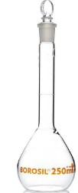
    - Name the following instruments. (6 mks)
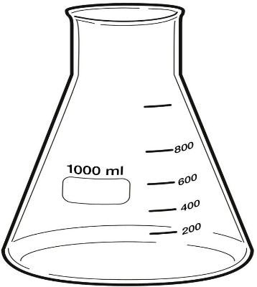
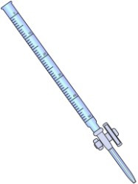

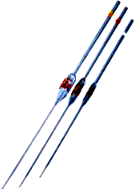
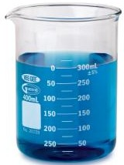
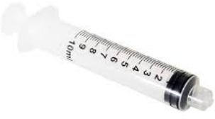

    - State three safe ways of Handling common laboratory apparatus and instruments (3 mks).
- ………………………………………………………………………
- ……………………………………………………………………
- …………………………………………………………………..

- Name four common accidents in the laboratory.(4 mks)
- …………………………………………………….
- …………………………………………………….
- …………………………………………………….
- …………………………………………………….

- Name four protective wear for safety in the laboratory.(4 mks)
- ………………………………………………………………
- ……………………………………………………………...
- ………………………………………………………………
- ……………………………………………………………...

- Name three laboratory apparatus used for measuring mass of substances.(3 mks)
- ………………………………
- ……………………………….
- ………………… ……………..

- Name three apparatus used for measuring length.(3mks)
- ………………………………….
- …………………………………
- ………………………………….

- Name the apparatus below. (1mk)

- Name the parts R, T and P above. (3mks)

R-………………………………………………..

T-………………………………………………..

P-……………………………………………

- Give four differences between luminous and non-luminous flame.(8 mks)
Luminous flame | Non-luminous flame

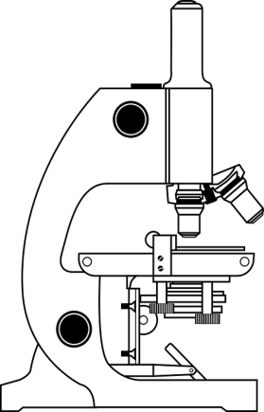
- Name the following parts of the light microscope.( 5 mks)

- Grade 8 students had their practical lesson in the laboratory.name two common accidents their Integrated Science teacher taught them. (2 mks)
- …………………………………….
- …………………………………….
- …………………………………….
- …………………………………….

- Name three protective wear for safety in the laboratory.( 3 mks)
- ………………………………………………
- ………………………………………………
- ……………………………………………….

- Calculate the area of the Circle whose diameter is 14cm. (2 mks)

14cm

- Outline three safe ways of handling of the Bunsen burner. (3 mks)
- …………………………………………………………………………
- …………………………………………………………………………
- …………………………………………………………………………

ENGLISH
ANC OFFERS KANU, ODM LOTS OF LESSONS

On January , Africa’s largest, oldest political party- the African National Congress
will be having her centenary celebrations. This would be a gigantic milestone for former South Africa Nelson Mandela’s party and it my passionate prayer he will be in a good shape to attend the momentous event.
The main event of the celebrations will be the presidential centenial gala dinner at Vista University in Free State to be hosted by President Jacob Zuma on January 7.
This will be a spectacle to behold Media reports have it that Zuma has extended official invitations to Kenya’s Prime Minister Raila Odinga and his deputy Uhuru Kenyatta to attend the January 7 event.
The ANC events provide us with an opportunity to reflect on the significance of our parties in shaping our country’s political, economic and social landscape. It would be prudent to ask ourselves whether our own political parties are anywhere in comparison to ANC. Have our parties fulfilled their mandate or have they only operated vehicles to ascend to power?

CONSCIENCE OF MANDATE
Raila Odinga sits at the helm of 0DM, which is currently Kenya’s largest political party while Uhuru is the chairman of Kenya’s oldest political party, Kanu. The two are therefore important in Kenya’s political landscape and deserve the ANC invitation. Kanu is currently re-inventing itself while 0DM has just concluded its grassroots election in compliance with the new Political Parties Act.
ANC was formed on January 8, 1912 in response to perceived injustices against black South Africans at the hands of the then white South African Government and has remained strong to date. ANC basically delivered its original mandate when it led South Africa in ending apartheid after the successful and fully-representative multi-democratic elections in 1994.
This was a big plus for ANC and will remain etched in the minds of South Africans and the world in general for a very long time.
Kanu is also credited with leading Kenya into independence; however, its leadership later took a completely different path which was nowhere near her original vision. After assuming power, it immediately engaged itself in an amazing plunder of national resources through mismanagement, tribalism, cronyism and political patronage.

Today, Kanu cannot boast of the kind of exploits ANC will be parading on January 8. 0DM should also be measuring itself against ANC.
Let this be an opportunity for Kenya’s political parties tot learn and reflect on what it means to exist for posterity.
(David Sonye, Nairobi)

- Identify the personal pronoun used with ANC and KANU? (1mks)
………………………………………………………………………………………………………
………………………………………………………………………………………………………
………………………………………………………………………………………………………

2. Name any two dignitaries officially invited to the event. (3mks) ………………………………………………………………………………………………………
………………………………………………………………………………………………………
………………………………………………………………………………………………………

3. Give three reasons why KANU cannot boast of the kind of exploits as ANC (3mks) ………………………………………………………………………………………………………
………………………………………………………………………………………………………
………………………………………………………………………………………………………

4. In a summary of about 25 words, write the lessons learnt from ANC ( 3 mks)
………………………………………………………………………………………………………
………………………………………………………………………………………………………
………………………………………………………………………………………………………

5. Explain the reasons why ODM and KANU were invited to the event. (3mks) ………………………………………………………………………………………………………
………………………………………………………………………………………………………
………………………………………………………………………………………………………

6. Where was the main object of ANC? ( 1mk)
………………………………………………………………………………………………………
………………………………………………………………………………………………………
………………………………………………………………………………………………………

7. The writer’s presentation of this passage is , objective. Give two examples as is evident ( 5mks)
………………………………………………………………………………………………………
………………………………………………………………………………………………………
………………………………………………………………………………………………………

8. Explain the meanings of the following words and phrases as used in the passage. ( 5mks)
i) Gigantic milestone ………………………………………………………………………………………………
………………………………………………………………………………………………

- Behold
………………………………………………………………………………………………
………………………………………………………………………………………………

- Reports have it
………………………………………………………………………………………………
………………………………………………………………………………………………

- Prudent
………………………………………………………………………………………………
………………………………………………………………………………………………

- Etched in the minds
………………………………………………………………………………………………
………………………………………………………………………………………………

2 Rewrite the following sentences according to the instructions given after each.
- What was stolen? (Change into active voice). (1mk)
………………………………..……………………………………………………………
..……………………………………………………………………………………………
………………………………………………………………………………………………

- Shut the door. (Add a question tag). (1mk)
………………………………..……………………………………………………………
..……………………………………………………………………………………………
………………………………………………………………………………………………

iii) I have never seen a more beautiful girl. (Rewrite beginning: This is……….) (1mk) …………….…………………..……………………………………………………………
..……………………………………………………………………………………………
………………………………………………………………………………………………

b) Fill in the blank spaces with the correct forms of the words given in brackets. (3mks)
i) Ndeko still wants more food even after clearing a whole plateful of ugali. His appetite is simply ___________________________________ (satisfy).
ii) After the inferno, the Roche’s had to buy new _________________(furnish) for their house.
iii) The___________________ (broad) of the material could not easily be established.
c) Supply one word which means the same as the underlined phrases in the following
sentences. (3mks)
i) The meeting was postponed after failing to realize the minimum required number of members.

ii) The telephone rang without stopping.

iii) The lawyer treated all those who required his services with respect.

d) i) Rewrite the following sentences replacing the underlined words with the appropriate phrasal verb. (3mks)
i) The circulated pamphlet made the meeting to be cancelled in the last minute. (call)

ii) They hired this bus as theirs was declared complete loss after the accident. (Write).

iii) I am surprised you cannot discover the deception in the lies he tells you. (see)

e) Insert the most appropriate prepositions in the blank spaces. (3mks)
i) Her performance was amazing ___________________any standards.
ii) Since he no longer runs the business, he has been reduced _____________begging.
- Traffic was moving___________________a snail’s pace.

- USE THE CORRECT FORM OF WORDS IN BRACKETS (5mks)

a) Amber was punished for being…………………………………(discipline)
b) Most African countries suffere from corruption and……………….(tribe)
c) Last July, I had the ……………………….of my life. (bad)
d) She is very ………………………………. (quarrel)
e) Your condition is…………………………..so don’t worry. (manage)

- FILL IN THE BLANKS WITH THE CORRECT COLLECTIVE NOUN. (5mks)
- A………………………………………..of directors.
- A………………………………………..of robbers.
- A……………………………………….of chicks.
- A…………………………………………of students.
- A………………………………………....of news.

UNDERLINE THE SILENT SOUNDS (5MKS)
- Honour
- Knife.
- Debt.
- Debris.
- Gnash

CRE
- What are the Similarities between biblical account and African creation stories
- ………………………………………………………………………………………..
- …………………………………………………………………………………………

- Ways in which Christians protect and care of animals, fish and birds
- ………………………………………………………………………………………..
- ………………………………………………………………………………………..
- ………………………………………………………………………………………..

- What are the Reasons why Christians take care of animals, fish and birds.
- …………………………………………………………………………………………
- …………………………………………………………………………………………
- ……………….………………………………………………………………………
- …………………………………………………………………………………………

- What are the Effects of Misusing Natural resources?
- …………………………………………………………………………………………
- …………………………………………………………………………………………
- ……………….………………………………………………………………………
- …………………………………………………………………………………………
- ………………………………………………………………….……………………...

- How is the Bible is used in different places and occasions
- …………………………………………………………………………………………
- …………………………………………………………………………………………
- ……………….………………………………………………………………………
- …………………………………………………………………………………………

- State the number of books in the following Divisions of the Bible
- Old testaments – ……………………………………
- New testaments – ……………………………………

- Why are there two divisions of the Bible

- …………………………………………………………………………………………

- …………………………………………………………………………………………

- ……………….…………………………………………………………………………

- …………………………………………………………………………………………

- Name two Major Prophets book writer

- ………………………………………………………………………………………

- ………………………………………………………………………………………

- What are the life skills needed to maintains healthy relationships?
- …………………………………………………
- …………………………………………………
- …………………………………………………
- …………………………………………………

- Name the Common drugs abused in Kenya
- ……………………………………………
- ……………………………………………
- ……………………………………………
- ……………………………………………
- …………………………………….………

- Reasons why young people abuse drugs today.
- ………………………………………………………………………………………
- ………………………………………………………………………………………
- ……………….………………………………………………………………………
- ………………………………………………………………………………………

- Give two examples of social media platforms used by young people today.
- …………………………………………………………………………………………
- …………………………………………………………………………………………

- What are the Dangers of Chatting or Meeting with online strangers?
- …………………………………………………………………………………………
- …………………………………………………………………………………………
- ……………….…………………………………………………………………………
- …………………………………………………………………………………………

- Which are some of the Way in which social media is misused today.
- …………………………………………………………………………………………
- …………………………………………………………………………………………
- ……………….………………………………………………………………………
- …………………………………………………………………………………………

- Discuss the meaning of studying CRE
- ………………………………………………………………………………………
- …………………………………………………………………………………………

- What is the Importance of studying CRE
- …………………………………………………………………………………………
- …………………………………………………………………………………………
- ……………….………………………………………………………………………
- …………………………………………………………………………………………

- How CRE helps us to relate well with others
- ………………………………………………………………………………………
- …………………………………………………………………………………………
- ……………….………………………………………………………………………
- …………………………………………………………………………………………

- Moral and religious values acquired from studying of CRE
- …………………………………………………………………………………………
- …………………………………………………………………………………………
- ……………….………………………………………………………………………
- …………………………………………………………………………………………

- Fill the created things according to the first creation account.
Day God’s creation
- First ……………………………………………………
- Second …………………………………………………..
- Third ………………………………………………
- Fourth ……………………………………………………
- Fifth ………………………………………………
- Sixth ……………………………………………..
- Seventh ……………………………………………………..

- Discuss the events in the second Biblical account of creation Genesis 2;4-25
……………………………………………………………………………………………………………………………………………………………………………………………………
……………………………………………………………………………………………………………………………………………………………………………………………………
………………………………………………………………………………………………………………………………………………………………………………………………………………………….

- Name the Attributes/nature of God from the Genesis stories of creation
- ………………………………………………………………………………………
- ………………………………………………………………………………………
- ……………….………………………………………………………………………
- ………………………………………………………………………………………

- What are the Similarities in the two biblical accounts of creation
- ………………………………………………………………………………………
- ………………………………………………………………………………………
- ……………….…………………………………………………………………………
- …………………………………………………………………………………………

- What are some of the Differences in the two biblical accounts of creation

First account | Second account

CREATIVE ARTS AND SPORTS
- What is drama?(2 mks)
…………………………………………………………………………………………………………………………………………………………………………………………………………

- Write down two importance of studying performing arts. (2mks)
- ……………………………………………………………………………………………..
- …………………………………………………………………………………………….

- What is the difference between performing arts and other arts. (2mks)
……………………………………………………………………………………………………………………………………………………………………………………………………………………………………………………………………………………………………………..

- Write down three elements of performing arts. (3mks)
- ……………………………………………………
- …………………………………………………..
- ………………………………………………….

- What is music? (2mks)
…………………………………………………………………………………………………………………………………………………………………………………………………………

- Identify the three sections of a narrative (3mks)
- …………………………………………………………….
- …………………………………………………………….
- ……………………………………………………………..

- State any four personal management skills you need to develop in sports. (4mks)
- ……………………………………………………………………………….
- ……………………………………………………………………………….
- ……………………………………………………………………………….
- ……………………………………………………………………………….

- The world Olympics competitions are held after………………. years. (1 mk)

- The ability of an athlete to maintain and stay in control of their body position whether static or in motion is called ………………………………………(2mks)

- List the three techniques in the flight stages of a long jump. (3mks)
- ………………………………………………..
- ………………………………………………..
- ……………………………………………….

- What is dribbling? (1mk)
…………………………………………………………………………………………………………………………………………………………………………………………………………

- Give the two common relay races in track events. (2mk)
- ………………………………………………..
- …………………………………………………

- List down any four senses arts can be experienced through. (4mks).
- ………………………………………….
- …………………………………………..
- …………………………………………..
- …………………………………………..

- List down two examples of written arts. (2mks)
- ……………………………………………
- ……………………………………………

- List down four resources that can be used in presentation. (4mks)
- ………………………………………….
- ………………………………………….
- …………………………………………..
- ………………………………………….

- When drawing components of perspective, three factors are considered. Name the factor (3mks)
- ……………………………………………..………………
- ………………………………………………………………
- ………………………………………………………………

- Write down four varieties of digital devices that are used in taking photographs. (2mks)
- ……………………………………………………………
- …………………………………………………………..
- …………………………………………………………..
- …………………………………………………………..

AGRICULTURE AND NUTRITION

- State five Ways of conserving vitamins and mineral salts in vegetables during food handling,preparation and cooking.(5 mks)
- ………………………………………………………………………….
- …………………………………………………………………………..
- …………………………………………………………………………..
- ………………………………………………………………………..
- ………………………………………………………………………….

- State five Ways to cook vegetables to preserve nutrients. (5 mks)
- …………………………………………………………………………….
- ………………………………………………………………………………
- ……………………………………………………………………….…….
- ………………………………………………………………………………
- ……………………………………………………………………………..

- Mention three Importance of Trees in conserving the environment.(3 mks)
  - ……………………………………………………………………………..
  - ………………………………………………………………………………
  - ………………………………………………………………………………

- Difference between afforestation, reforestation and deforestation.(6 mks)
…………………………………………………………………………………
……………………………………………………………………………………
…………………………………………………………………………………
……………………………………………………………………………
…………………………………………………………………………………
……………………………………………………………………………………
…………………………………………………………………………………….

- State four Roles of trees in soil and water conservation. (4 mks)
  - ………………………………………………………………..
  - ……………………………………………………………….
  - ………………………………………………………………….
  - ………………………………………………………………….
- What is Agroforestry? (2 mks)
……………………………………………………………………………………………………………………………………………………………………………………………..

- Name three minimum tillage practices for water conservation carried out in farming. (3mks)
- ……………………………………………..
- ……………………………………………..
- ………………………………………………

- Name three practices carried out when caring for agroforestry trees. (3mks)
- ………………………………………………………………………………..
- ………………………………………………………………………………..
- ……………………………………………………………………………….

- State and explain four nursery management practice done in a tree nursery. (8 mks)
- ……….....................................................................................................
- ………………………………………………………………………
- …………………………………………………………………….

- Give three examples of crops that require fine tilth include(3 mks)
- …………………………….
- …………………………….
- …………………………….

21. Mention two Examples of crops that require medium tilth. (2 mks)
- ……………………………………….
- ……………………………………….
- State two reasons for sorting and grading eggs. (2 mks)
- …………………………………………………………………………………
- ……………………………………………………………………………….

- State five factors to consider when Sorting and Grading Eggs (5 mks)
  - ………………………………………………………………………………….
  - …………………………………………………………………………………..
  - …………………………………………………………………………………
  - …………………………………………………………………………………
  - …………………………………………………………………………………..

- Outline four importance of sorting and grading eggs.(4 mks)
- ……………………………………………………………………………
- ……………………………………………………………………………
- ……………………………………………………………………………
- ……………………………………………………………………………

- Outline the Steps followed when processing honey.(5 mks)
- …………………………………………………………………………………
- …………………………………………………………………………………
- …………………………………………………………………………………
- ………………………………………………………………………………....
- ……………………………………………………………………………….

- State three reasons for performing the following precautions when Packing Honey. (3 mks)
- …………………………………………………………………
- …………………………………………………………………
- …………………………………………………………………

- State four Importance of Processing Raw Honey.(4 mks)
- …………………………………………………………………………………
- …………………………………………………………………………………
- …………………………………………………………………………………
…………………………………………………………………………………

ENGLISH.
COMPOSITION (20mrks)
Instructions: Begin your composition with the following words,
It was my first day, first lesson in high school. The English teachers’ footsteps could be heard far away from the door………………………………………………….
………………………………………………………………………………………………………………………………………………………………………………………………………………………………………………………………………………………………………………………………………………………………………………………………………………………………………………………………………………………………………………………………………………………………………………………………………………………………………………………………………………………………………………………………………………………………………………………………………………………………………………………………………………………………………………………………………………………………………………………………………………………………………………………………………………………………………………………………………………………………………………………………………………………………………………………………………………………………………………………………………………………………………………………………………………………………………………………………………………………………………………………………………………………………………………………………………………………………………………………………………………………………………………………………………………………………………………………………………………………………………………………………………………………………………………………………………………………………………………………………………………………………………………………………………………………………………………………………………………………………………………………………………………………………………………………………………………………………………………………………………………………………………………………………………………………………………………………………………………………………………………………………………………………………………………………………………………………………………………………………………………………………………………………………………………………………………………………………………………………………………………………………………………………………………………………………………………………………………………………………………………………………………………………………………………………………………………………………………………………………………………………………………………………………………………………………………………………………………………………………………………………………………………………………………………………………………………………………………………………………………………………………………………………………………………………………………………………………………………………………………………………………………………………………………………………………………………………………………………………………………………………………………………………………………………………………………………………………………………………………………………………………………………………………………………………………………………………………………………………………………………………………………………………………………………………………………………………………………………………………………………………………………………………………………………………………………………………………………………………………………………………………………………………………………………………………………………………………………………………………………………………………………………………………………………………………………………………………………………………………………………………………………………………………………………………………………………………………………………………………………………………………………………………………………………………………………………………………………………………………………………………………………………………………………………………………………………………………………………………………………………………………………………………………………………………………………………………………………………………………………………………………………………………………………………………………………………………………………………………………………………………………………………………………………………………………………………………………………………………………………………………………………………………………………………………………………………………………………………………………………………………………………………………………………………………………………………………………………………………………………………………………………………………………………………………………………………………………………………………………………………………………………………………………………………………………………………………………………………………………………………………………………………………………………………………………………………………………………………………………………………………………………………………………………………………………………………………………………………………………………………………………………………………………………………………………………………………………………………………………………………………………………………………………………………………………………………………………………………………………………………………………………………………………………………………………………………………………………………………………………………………………………………………………………………………………………………………………………………………………………………………………………………………………………………………………………………………………………………………………………………………………………………………………………………………………………………………………………………………………………………………………………………………………………………………………………………………………………………………………………………………………………………………………………………………………………………………………………………………………………………………………………………………………………………………………………………………………………………………………………………………………………………………………………………………………………………………………………………………………………………………………………………………………………………………………………………………………………………………………………………………………………………………………………………………………………………………………………………………………………………………………………………………………………………………………………………………………………………………………………………………………………………………………………………………………………………………………………………………………………………………………………………………………………………………………………………………………………………………………………………………………………………………………………………………………………………………………………………………………………………………………………………………………………………………………………………………………………………………………………………………………………………………………………………………………………………………………………………………………………………………………………………………………………………………………………………………………………………………………………………………………………………………………………………………………………………………………………………………………………………………………………………………………………………………………………………………………………………………………………………………………………………………………………………………………………………………………………………………………………………………………………………………………………………………………………………………………………………………………………………………………………………………………………………………………………………………………………………………………………………………………………………………………………………………………………………………………………………………………………………………………………………………………………………………………………………………………………………………………………………………………………………………………………………………………………………………………………………………………………………………………………………………………………………………………………………………………………………………………………………………………………………………………………………………………………………………………………………………………………………………………………………………………………………………………………………………………………………………………………………………………………………………………………………………………………………………………………………………………………………………………………………………………………………………………………………………………………………………………………………………………………………………………………………………………………………………………………………………………………………………………………………………………………………………………………………………………………………………………………………………………………………………………………………………………………………………………………………………………………………………………………………………………………………………………………………………………………………………………………

